Moving with Pets: What You Should Know
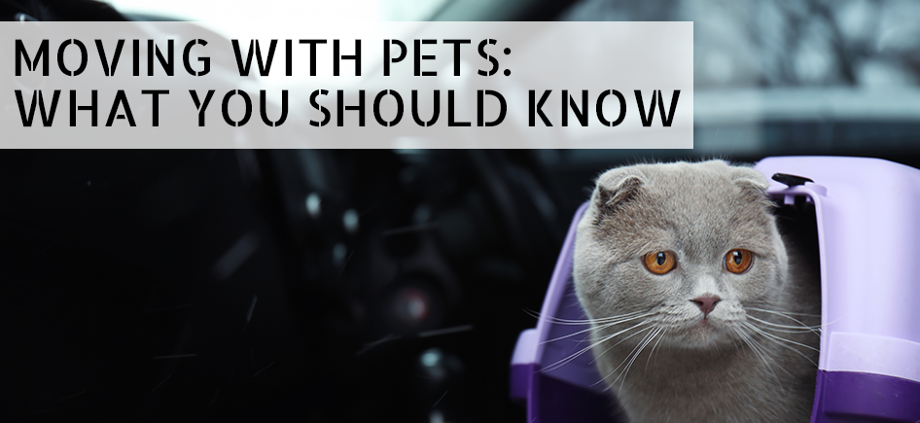
If you are planning a removal and you have pets, you need to make sure your pet is secured on moving day. You do not want to move to a new house with your pet unless you make sure that your dog or cat is safely out of the way of the movers. A pet that is left loose when moving day arrives can either get lost or become disoriented. If it is a dog, he or she may disrupt the movers’ progress. That is why you do not want to make your dog or cat part of the moving day activities.
Keep Your Pet Out of Sight
If you can do so, you should arrange to have your pet watched by a close neighbour or friend whilst you are having your belongings packed and transported. You really do not want to have your cat or dog hanging around the house when removalists in Sydney begin moving your belongings. Doing so could end up in disaster.
Plus, your pet could become seriously injured when the removal is taking place and the Sydney removalists are moving your furniture. For example, a mover may not see your dog and hit it with a piece of furniture and hurt it. Also, your pet could run out in the street and get struck by a car. In either of these cases, you could prevent these incidents from happening. That is why you do not want you pet hanging around the house.
Introduce Your Pet to Its New House
Pets also feel nervous when they are taken out of their regular environments. Therefore, it is important before you move to introduce your pet to its new house. That way, he or she will feel more comfortable when you finally take that drive, on moving day, to your new residence. The last thing you want to do is to acquaint your dog or cat with your new home on your move-in date. Doing so may scare him or her and he or she might even run away.
Also, it is imperative, when moving home, that you make sure your cat or dog is microchipped. This process is very simple and will ensure that you can find your pet if he or she gets nervous and happens to get loose or run away. Micro-chipping involves inserting a very small computerised chip into the scruff of an animal. The chip can be scanned if you pet is found and taken, for instance, to a shelter.
Ensure Your Pet’s Safety
Micro-chipping services include adding your pet’s name to a database – a compilation of pet names and owner addresses that are accessed by shelters and similar facilities. You also should include your phone number on a tag on the collar your pet is wearing. By taking these measures, you can ensure that you can relocate your pet should he or she become nervous and get away from you. Otherwise, if you have a dog, make sure he or she is leashed and that your cat is in a cat carrier when you move home. That way, you can keep track of your animals and ensure their safety during the relocation.

